CRITERION-1

SUPPORTING DOCUMENT AND EVIDENCES AS PER SOP

---0---

|  |  |
| --- | --- |
| **METRIC NO 1.3.2** | Percentage of students undertaking project work/ Fieldwork/ Internships (Data for latest completed academic years) |
| Approved Students list with topic of project of various courses which includes Project works | |

|  |  |  |
| --- | --- | --- |
| **S.No.** | **Student list of courses which includes Project works** | **Subject** |
| 1 | B.A. Part One | **Environmental Studies** |
| 2 | B.Sc. Part One | **Environmental Studies** |
| 3 | B.Com. Part one | **Environmental Studies** |
| 4 | B.Sc. Part Three | **Botany** |

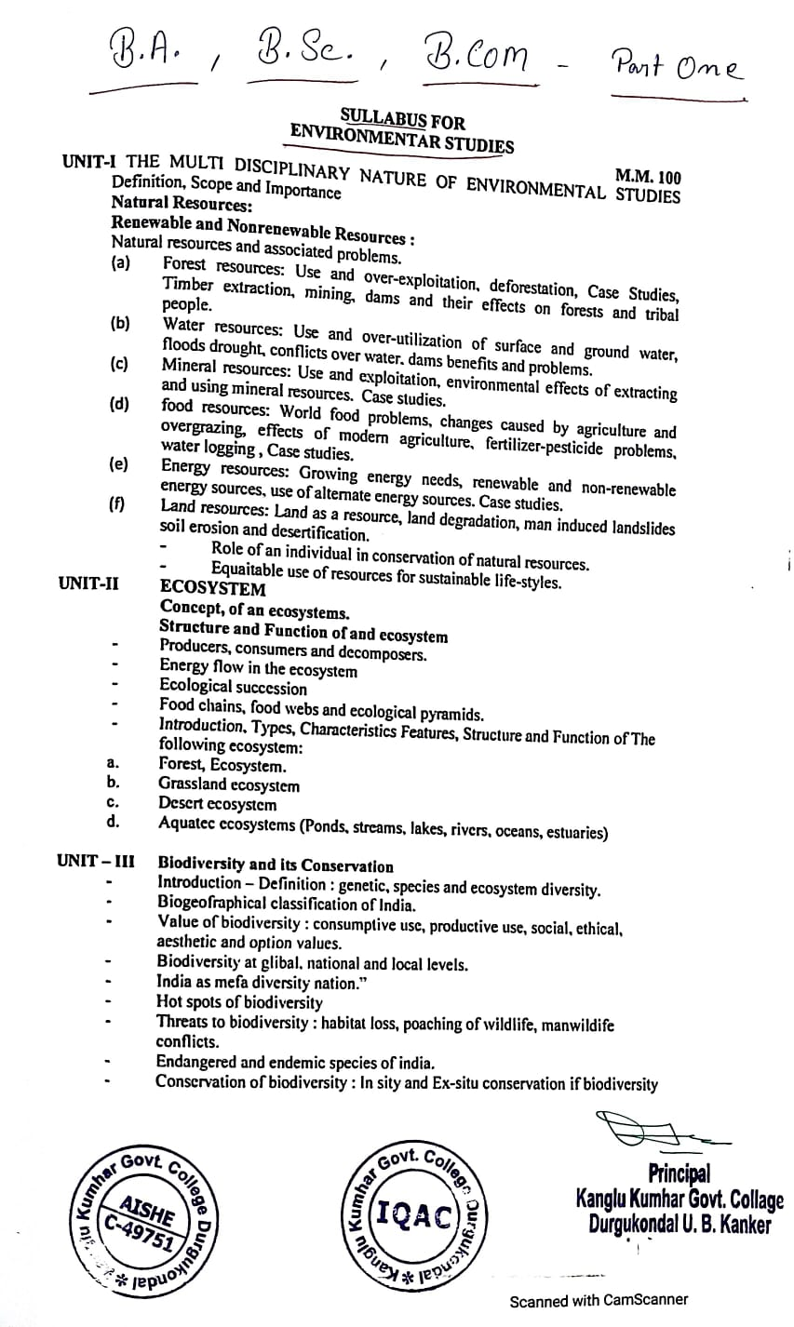

**B.A Part One, B.Sc Part One & B.Com Part One**

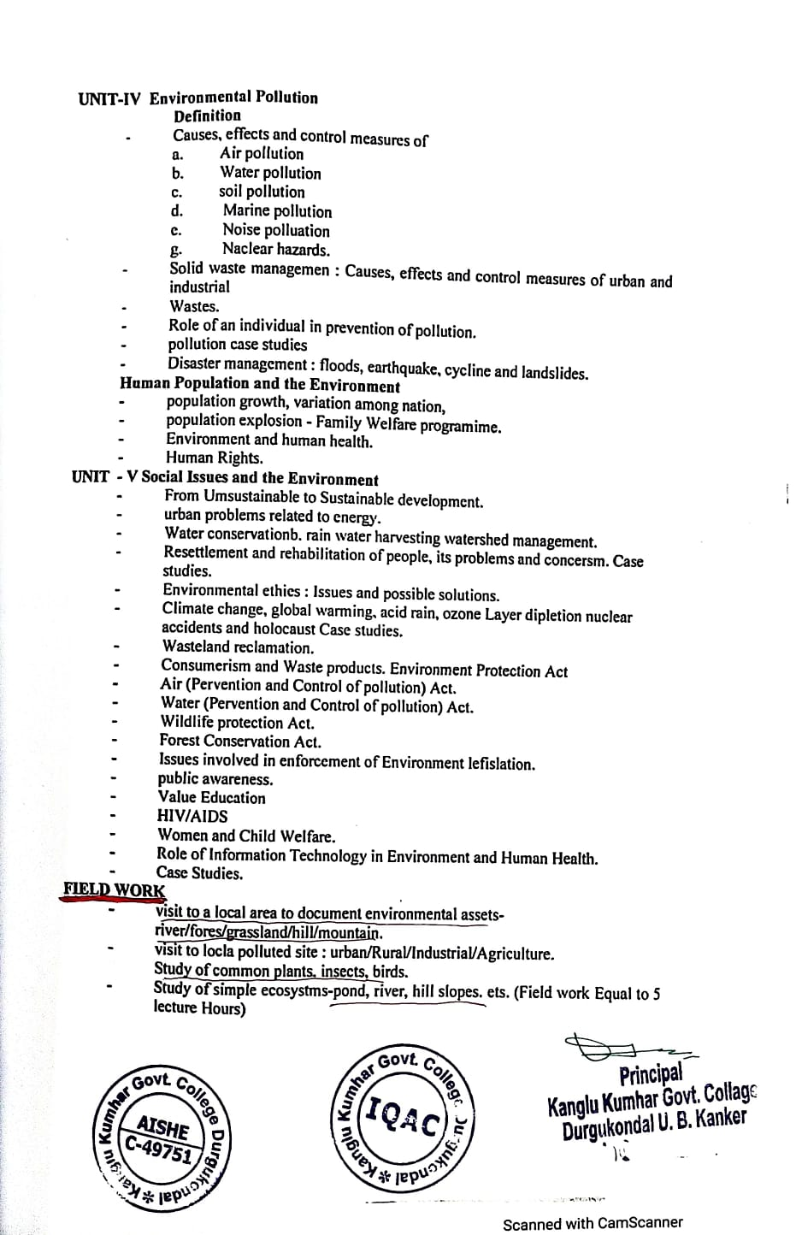



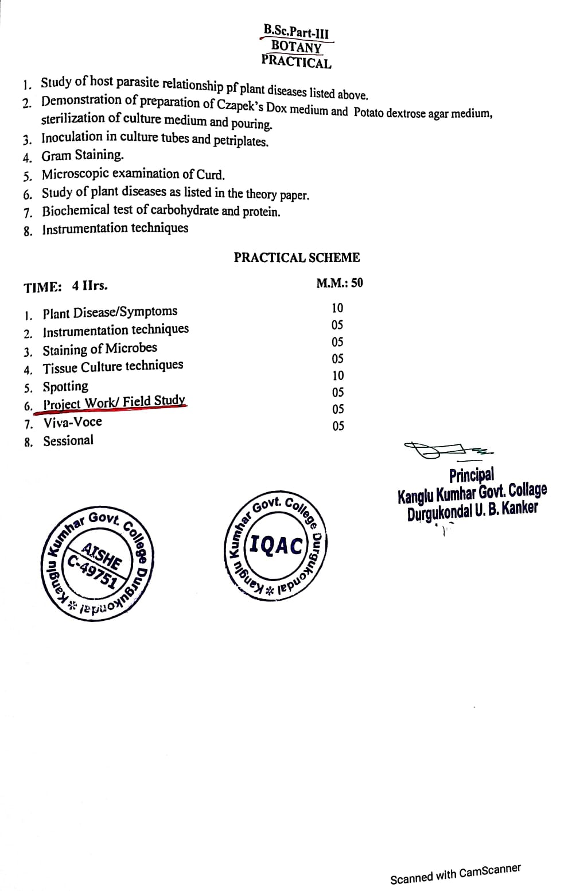



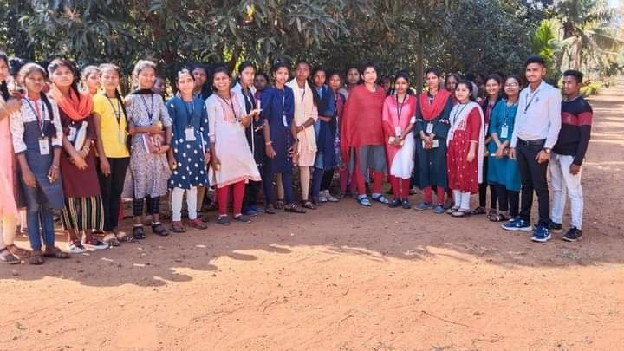

**A Visit to Nearby Nursery by the Student of B.Sc. Part Three for Their Field work And Study of Plants**

